MEC Community Information Hub
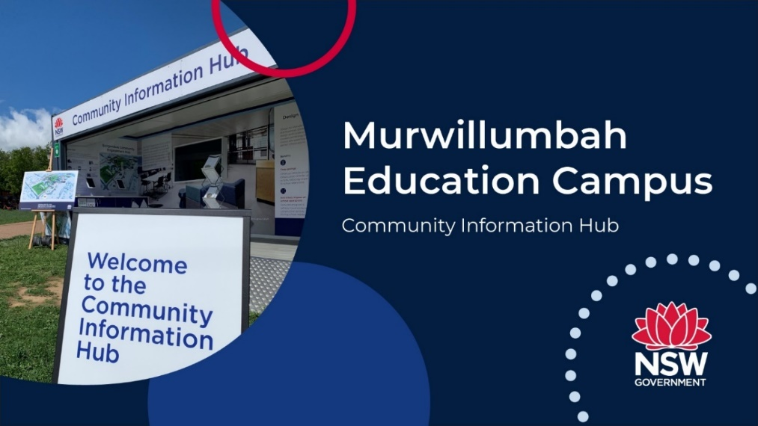
The community is invited to attend a Community Information Hub to find out more about the progress of the Murwillumbah Education Campus project.
We understand that for many in our community now will not be the right time for attending an event like this but we also think it’s important that we continue providing access to information about the project.
At the hub you will be able to view some selected plans from the State Significant Development (SSD) application, which is due to be lodged with the NSW Department of Planning and Environment (DPE) in the coming weeks. You will also be able to talk with members of the project team as well as the principals who have been appointed to lead the new schools at the campus.
The hub will be open in Knox Park at selected times between Tuesday 5 and Thursday 7 April 2022. To view opening hours and book your visit go to www.edu.nsw.link/MEC. For those that can’t attend, the materials will be published to the project website from Friday 8 April 2022. DPE will also notify the community once the SSD application is on public exhibition.

